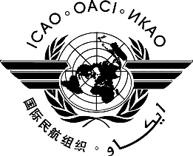 | International Civil Aviation Organization  WORKING PAPER | A41-WP/xxx  EC/xx  ../../22  (Information paper)  English only
ASSEMBLY — 41ST SESSION

ECONOMIC COMMISSION

Agenda Item | ##: | Title of agenda item

TITLE

(Presented by ...)

EXECUTIVE SUMMARY
Start text here
Strategic Objectives: | This working paper relates to Strategic Objectives...
Financial implications:
References:

- INTRODUCTION
  - ...

